1️⃣ What is Port Security (Static MAC)?
Point-wise:
- A switch security feature that limits which MAC address can access a port.
- You manually configure the specific MAC addresses allowed on that port.
- If any other device connects → switch triggers a violation.
- Helps prevent unknown, unauthorized, or malicious devices from joining the network.
- Works only on access ports (not on trunk ports).
- Has 3 violation modes: protect, restrict, shutdown.
- Commonly used in offices, servers, CCTV, printers, etc.

2️⃣ Why do we configure Static MAC Port Security?
Point-wise:
- To block unauthorized devices.
- To stop MAC-flooding attacks.
- To ensure only known, approved devices connect.
- To protect network from users connecting rogue switches/hubs.
- To maintain strict device-to-port mapping.
- To increase security without requiring complex authentication systems like 802.1X.
- To prevent network changes in sensitive areas (server rooms, backbone).
- To ensure predictable and controlled traffic.

3️⃣ Advantages (Pros)
Point-wise:
- High security — only configured MACs allowed.
- Prevents unauthorized access.
- Protects against MAC table overflow/flooding attacks.
- Ensures device consistency per port.
- Blocks users from connecting their own devices.
- Reduces risk of loops caused by unmanaged switches/hubs.
- Good for IoT, CCTV, printers, where MAC never changes.
- Helps in asset and port tracking.

4️⃣ Disadvantages (Cons)
Point-wise:
- High administrative work — MACs must be manually configured.
- When a user changes laptop/PC → new MAC not allowed → port shuts down.
- Not scalable in large networks.
- Can cause accidental port shutdowns if MAC is wrong.
- Can be bypassed by MAC spoofing (attacker fakes allowed MAC).
- Does not protect data — no encryption.
- Troubleshooting increases because ports often go into err-disable mode.

Configuration:
enable
configure terminal
hostname SW1

! Step 1: Make port access port
interface fa0/1
switchport mode access
switchport access vlan 10

! Step 2: Enable port security
switchport port-security

! Step 3: Allow ONLY 1 MAC address on this port
switchport port-security maximum 1

! Step 4: Configure STATIC allowed MAC address
switchport port-security mac-address 00d0.ba11.2233
(replace with your PC MAC)

! Step 5: Violation mode (recommended: shutdown)
switchport port-security violation shutdown

! Step 6: Enable port
no shutdown
exit

verification:
Test 1: Connect correct PC
✔ Link works
✔ Ping works
✔ No violation
Test 2: Disconnect PC & connect another one
❌ Port will go err-disabled
❌ Ping fails
❌ "Link down" shows
en
config t
hostname INBOM25CS01
vlan 10
name wired_PC
ex

!-- SVI interfaces
interface vlan 10
ip address 192.168.10.1 255.255.255.0
no shutdown
exit

! ---- DHCP POOLS ----
ip dhcp pool SALES
network 192.168.10.0 255.255.255.0
default-router 192.168.10.1
dns-server 8.8.8.8
exit

! Access ports
interface range gi1/0/1 - 2
switchport mode access
switchport access vlan 10
no shutdown
exit

! port security
interface gi1/0/1
switchport port-security
switchport port-security mac-address 0030.F243.D902
switchport port-security maximum 1
switchport port-security violation restrict
no shutdown
ex

interface gi1/0/2
switchport port-security
switchport port-security mac-address 0090.2187.55D7
switchport port-security maximum 1
switchport port-security violation shutdown
no shutdown
ex
ex

Working
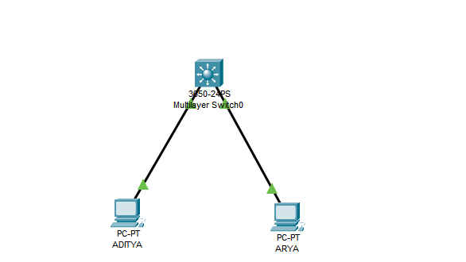

Failed when another connected
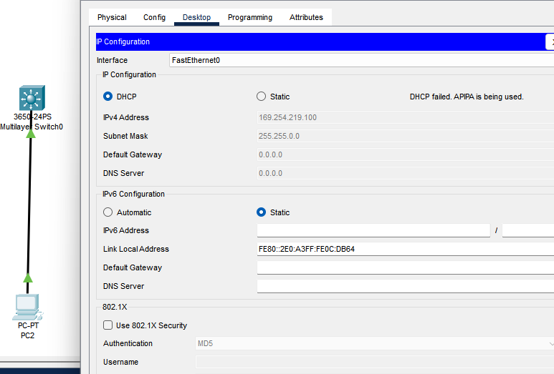
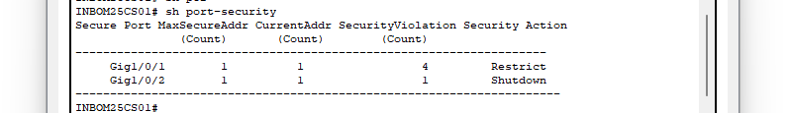S

